Member Functions:

1. SignUpWindow() – moves to SignUp_wins()
2. SignInWindow() – moves to LogIn_win()

Member Functions:

1. Input_data () – inputs data into mysql table – users_details. Moves to LogIn_win()
2. Next() – moves to Sign Up page 2

Home_win()

Main Program

SignUp_wins()

Member Functions:

1. LogIn() – checks whether the record of the user is in mysql table.

LogIn_win()

book()

Mysql connectivity

After_LogIn_win()

Hire_Book_OP_win()

Member Functions:

1. book() – Allows booking bus ticket(s)/hiring a bus by moving to Hire_Book_OP_win().
2. edit() – Allows editing one’s user details by moving to Edit_Pro_win().
3. logout() – Pops a yes/no window to logout.

Member Functions:

1. Validate2() – enables Book button.
2. HireBus() – Allows user to hire a bus.
3. BookTicket() - Allows user to book a bus ticket by moving to Book_Tic_win().
4. main()

Book_Tic_win ()

Member Functions:

1. Validate() – enables ‘Find Buses’ button.
2. Validate2() – enables Book button.
3. Find_Bus() – Finds buses from table – Bus_stand.

Edit_Pro_win()

Member Functions:

1. Editname() – Edits users’ username.
2. EditPassword() – Edits users’ password.
3. EditPhone() – Edits users’ phone number.
4. Editmail() - Edits users’ mail ID.

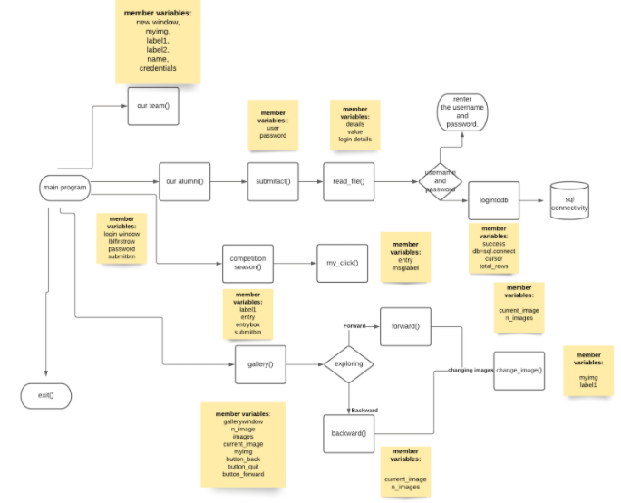

Member Functions:

1. SignUpWindow() – moves to SignUp_wins()
2. SignInWindow() – moves to LogIn_win()

Member Functions:

1. Input_data () – inputs data into mysql table – users_details. Moves to LogIn_win()
2. Next() – moves to Sign Up page 2

Home_win()

Main Program

SignUp_wins()

Member Functions:

1. LogIn() – checks whether the record of the user is in mysql table.

LogIn_win()

book()

Mysql connectivity

After_LogIn_win()

Hire_Book_OP_win()

Member Functions:

1. book() – Allows booking bus ticket(s)/hiring a bus by moving to Hire_Book_OP_win().
2. edit() – Allows editing one’s user details by moving to Edit_Pro_win().
3. logout() – Pops a yes/no window to logout.

Member Functions:

1. Validate2() – enables Book button.
2. HireBus() – Allows user to hire a bus.
3. BookTicket() - Allows user to book a bus ticket by moving to Book_Tic_win().
4. main()

Book_Tic_win ()

Member Functions:

1. Validate() – enables ‘Find Buses’ button.
2. Validate2() – enables Book button.
3. Find_Bus() – Finds buses from table – Bus_stand.

Edit_Pro_win()

Member Functions:

1. Editname() – Edits users’ username.
2. EditPassword() – Edits users’ password.
3. EditPhone() – Edits users’ phone number.
4. Editmail() - Edits users’ mail ID.